Version Number：TIJ20240528

T220E Series

High Resolution Inkjet Printer

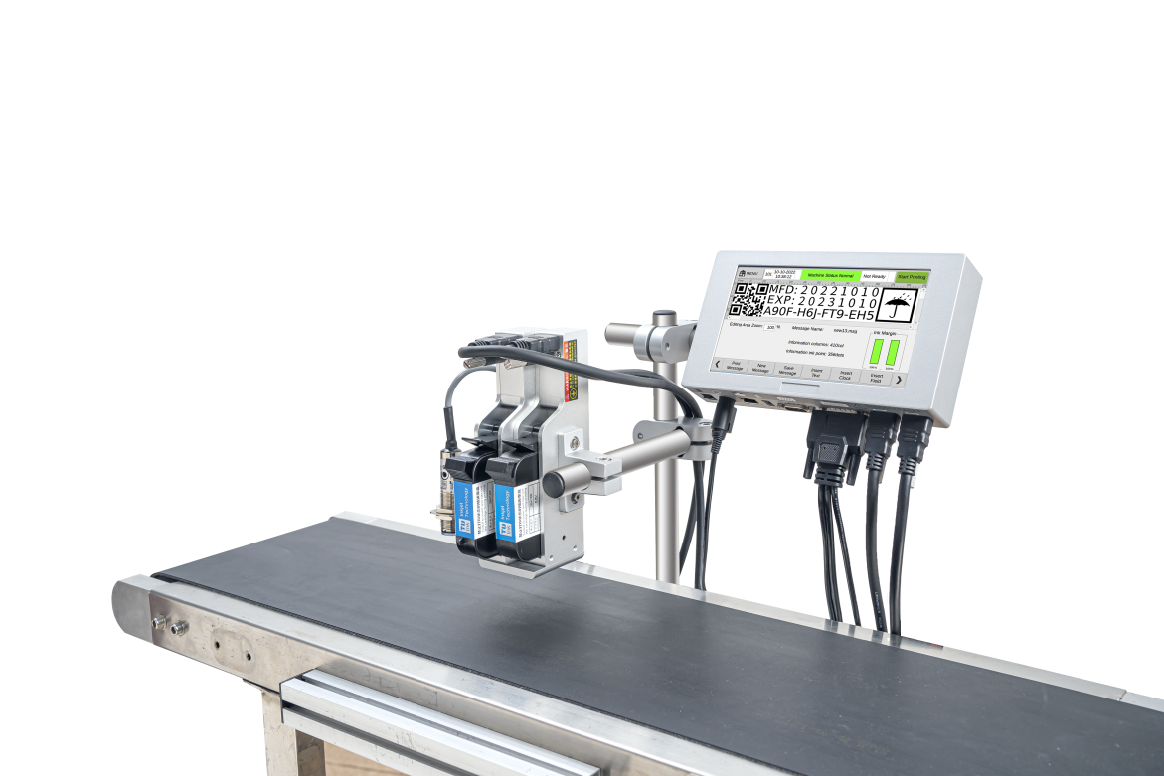

OPERATION AND MAINTENANCE

MANUAL

Contents

[Significant issues 4](#_Toc19368)

[Safety Notes 4](#_Toc22748)

[Preface 5](#_Toc3078)

[How to Use this Instruction 5](#_Toc24611)

[Chapter1 Matters needing attention in the use of inkjet printer 6](#_Toc24873)

[1.1 Installation Precautions 6](#_Toc21363)

[1.2 Operational considerations 7](#_Toc5174)

[Chapter2 Installation Notes 8](#_Toc25592)

[2.1 Packing List 8](#_Toc29631)

[2.2 Equipment Description 9](#_Toc26547)

[Chapter 3 Port Introduction 10](#_Toc174)

[3.1 External ports 10](#_Toc31525)

[3.2 Technical specifications 11](#_Toc4026)

[Chapter 4 Quick Start Guide 12](#_Toc2429)

[4.1 Confirm before use 12](#_Toc27486)

[4.2 Quick steps 12](#_Toc14123)

[4.3 Check after use 14](#_Toc8870)

[Chapter 5 Instruction of inkjet printer 15](#_Toc18940)

[5.1 Main menu interface 15](#_Toc21332)

[5.2 Message 16](#_Toc17201)

[5.2.1 Insert text 17](#_Toc29216)

[5.2.2 Insert clock 18](#_Toc17195)

[5.2.3 Insert field 18](#_Toc27183)

[5.2.4 Insert 2D code 19](#_Toc19366)

[5.2.5 Insert Barcode 20](#_Toc29929)

[5.2.6 Insert Logo 21](#_Toc23704)

[5.2.7 Insert Shift 22](#_Toc21975)

[5.2.8 Serial number 22](#_Toc2344)

[5.2.9 Database 23](#_Toc16953)

[5.2.10 Insert GS1 code 24](#_Toc19815)

[5.2.11 Weight price 25](#_Toc14955)

[5.3 File Storage 26](#_Toc29349)

[5.3.1 Message 26](#_Toc2902)

[5.3.2 Logo 27](#_Toc32665)

[5.3.3 Fonts 27](#_Toc8315)

[5.3.4 Data file 28](#_Toc23232)

[5.3.5 Report file 28](#_Toc21348)

[5.4 Print parameters 28](#_Toc14479)

[5.4.1 Print width 29](#_Toc2936)

[5.4.2 Delay stitch 30](#_Toc31862)

[5.4.3 Invert Reverse 30](#_Toc22911)

[5.4.4 Print Mode 31](#_Toc10953)

[5.4.5 Cartridge parameter 33](#_Toc21608)

[5.4.6 Dynamic Settings 34](#_Toc15105)

[5.4.7 Simulate Printing 34](#_Toc26887)

[5.5 Machine parameters 35](#_Toc21748)

[5.5.1 System settings 35](#_Toc7390)

[5.5.2 Date format 36](#_Toc6396)

[5.5.3 Time format 36](#_Toc1083)

[5.5.4 Base format 37](#_Toc21028)

[5.5.5 Month, week, hour code 38](#_Toc28202)

[5.5.5 Common texts 39](#_Toc7434)

[5.5.6 Product count 39](#_Toc32606)

[5.5.7 Communication settings 40](#_Toc22733)

[5.5.8 Screen Adjust 41](#_Toc2096)

[5.6 Service menu 41](#_Toc20517)

[5.6.1 System settings 42](#_Toc6745)

[5.6.2 Print Settings 42](#_Toc10288)

[5.6.3 User Management 45](#_Toc328)

[5.6.4 Event Log 45](#_Toc22105)

[Chapter 6 Maintenance and Maintenance 46](#_Toc15749)

[6.1 Inkjet printer maintenance 46](#_Toc32405)

[6.2 Cartridge maintenance 47](#_Toc6811)

[Chapter 7 Common Problems and Solutions 49](#_Toc8220)

[7.1 Warning bar information status and solution 49](#_Toc23885)

[7.1.1 Display green 49](#_Toc27981)

[7.1.2 Display yellow 49](#_Toc5253)

[7.1.3 Display red 50](#_Toc20326)

[7.2 Common problems and solutions of ink cartridges 51](#_Toc10905)

[7.3 Common problems and solutions of inkjet printers 53](#_Toc23851)

# Significant issues

* **When the machine is powered on, it is forbidden to plug or unplug any cables!**
* **Do not unplug ink cartridges in printing status!**
* **In order to ensure that the machine achieves the best printing results, it is recommended to use the specified model of ink and accessories. Non-specified models of ink and accessories can easily cause problems such as machine failure and poor printing results.**
* **Equipment failures caused by failure to follow this manual are not covered by the product warranty.**

# 

# Safety Notes

After the printer is powered on, there is high voltage inside the machine. It is forbidden to carry out maintenance and disassembly of the equipment without professional training and unauthorized personnel to avoid accidents.

　　When installing the printer, you must install a ground wire, and confirm that your ground wire is reliably connected to the earth; if the ground wire is not reliably connected, the device may not work properly.

　　 Do not place the ink in direct sunlight or high temperature storage (over 35°), otherwise it will affect the ink jet printing effect and shelf life.

　　If ink accidentally splashes on your eyes or skin during use, please rinse it off with water immediately.

If the ink leaks into the printer, please immediately shut down and cut off the power; when the ink penetrates into the device, please ask a professional to check, otherwise it will cause the device to burn.

The following symbols are used in the manual. If these symbols appear next to a program or caution side, then they have the same importance as the written warnings and tips.



Must wear protective glasses.



Must wear protective overalls. use suitable protective gloves. Check the relevant safety data sheet (SDS).



The power supply of the equipment must be disconnected.



This step can only be done by trained personnel.



Be careful with electrostatic discharge (ESD). Anti-static measures must be taken.

Wear a grounded antistatic wristband.

• Do not wear clothing that may accumulate electrostatic voltages.

• Antistatic (ESD) protective bags should be used when shipping printed circuit boards.

• Printed circuit boards can only be placed on mats made of materials that eliminate electrostatic voltages and are properly grounded.



**Please note**

Before using this inkjet printer, please read this instruction to avoid loss.

# Preface

This manual is the instruction manual of T220E high resolution inkjet printers. We hope it can bring help to your work.

This manual is used to guide the operator how to use the printer, it contains the following contents:

Precautions for use Introduction of inkjet printer Introduction to the composition of inkjet printer

Installation instructions Introduce the installation instructions

Starting the printer Introduce the general quick operation of the printer, start/stop the printer

Operating instructions Explain in detail how to create/edit printing data and related settings of the printer

Maintenance Arrangements for maintenance of printers and ink cartridges

Troubleshooting About common printer and ink cartridge failures and solutions

# 

# How to Use this Instruction

Before the first use of the inkjet printer, please read this manual carefully, please pay attention to the relevant matters; when you encounter problems in the process of use, please first check the corresponding chapters and record the relevant problems; if still can not be resolved, please contact us.

The Company has the right to regularly update the contents of this specification without prior notice. The update will be added to the new version of the specification.

Note: Equipment failure caused by failure to operate according to this specification is not covered by warranty.

# Chapter1 Matters needing attention in the use of inkjet printer

Thank you for using this printer, in order to ensure personal safety and machine installation, ease of use and ensure that you can make full use of the machine's features, for your rights, please read this instruction carefully.



## 1.1 Installation Precautions

1.1.1 The power supply of the printer should avoid sharing power with other equipment. It is recommended to install an uninterruptible power supply (UPS);

1.1.2 The bracket should be avoided to be installed in the location with vibration or swing;

1.1.3　 High-quality printing requires a stable production line or conveyor belt;

1.1.4　 The production line is equipped with guide plates to prevent the printed materials from hitting the nozzle and causing damage to the equipment;

1.1.5　 Ensure that the printer is well grounded;

1.1.6　 The distance between the guide plate of the printer body and the object to be printed is recommended to be 0.5-2.5mm;

1.1.7　 When installing or removing ink cartridges, please make sure to insert and remove the ink cartridges at a 15 angle to avoid damage to the ink cartridges;

1.1.8　 Do not install the machine in an environment with too much dust for a long time.If the environment customer cannot change it, the dust must be removed regularly.



## 1.2 Operational considerations

1.2.1 　 Touch screen is prohibited to poke and collide with hard objects;

1.2.2　　Eye of the equipment must not be blocked, otherwise it will cause inability to print;

1.2.3　　When the printing effect is missing or blurred, please use non-woven cloth to wipe the nozzle surface;

1.2.4　　When the printing position changes, please set the printing delay to achieve the best printing effect;

1.2.5 　 Do not insert or remove the ink cartridge in the printing state to avoid damage to the machine circuit;

1.2.6　　It is strictly forbidden to use compressed air to directly clean the touch screen, high-pressure compressed air will damage the touch screen;

1.2.7 It is strictly forbidden to use compressed air to directly or indirectly clean the ink cartridge, which will damage the ink cartridge;

1.2.8　When the printer fails, please refer to Chapter 7 for solutions to common problems.

To solve the fault, please contact our after-sales service department.

**Note: According to the characteristics of different models of ink, some models of ink cartridges must be pulled out after the printing machine is turned off, wipe the nozzle surface with a non-woven cloth and use the cartridge clamp to prevent the nozzle from clogging (details please Consult our after-sales service for relevant ink characteristics).**

# Chapter2 Installation Notes

This chapter introduces the product packing list, equipment and ink cartridge installation.

## 2.1 Packing List

When you open the package, please check each part one by one according to this packing list to confirm whether id is complete.If there is any omission, please consult us immediately.

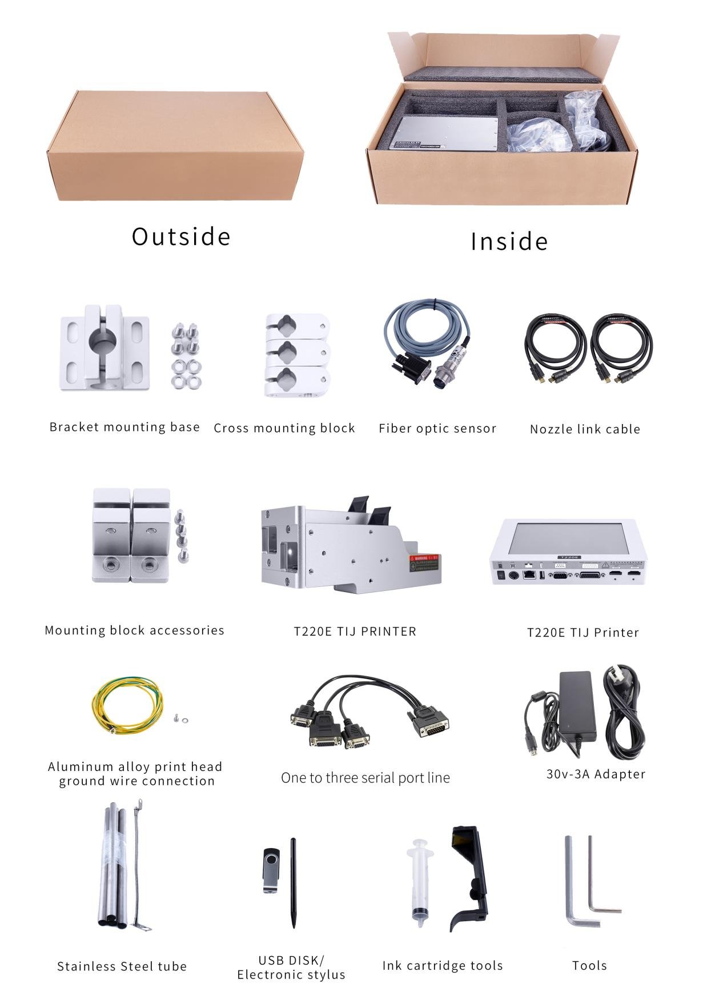

Figure 2-1

## 2.2 Equipment Description

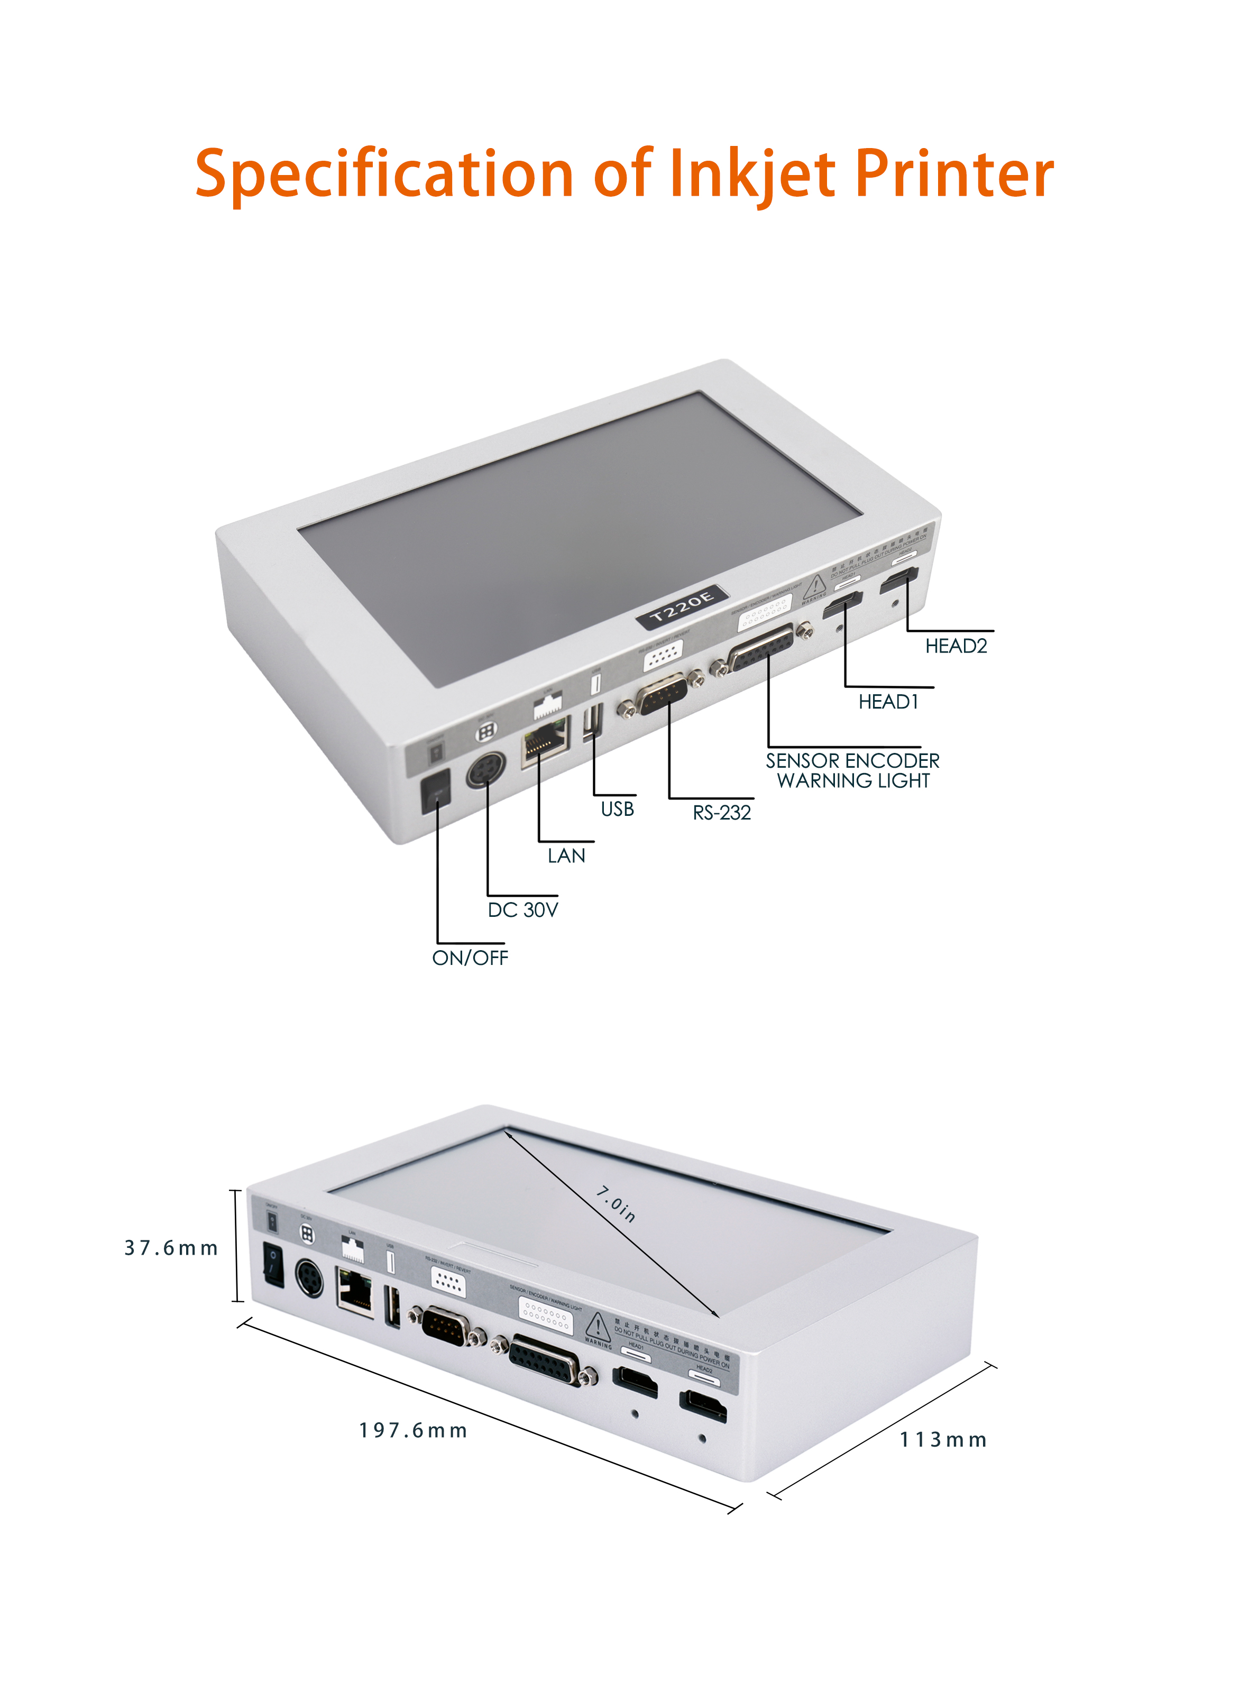

Figure 2-2

T220E Online inkjet thermal inkjet printer-host

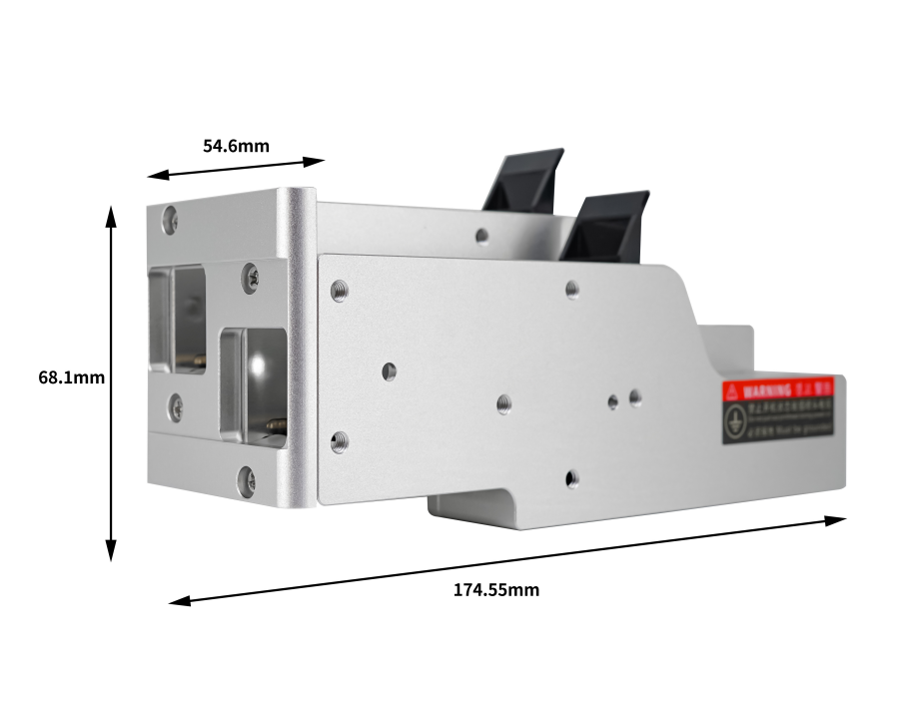

Figure 2-3

T220E Online inkjet thermal inkjet printer-print head

# Chapter 3 Port Introduction

3.1 External ports

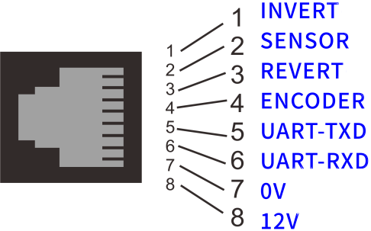

Figure 3-1 T220E Online inkjet thermal inkjet printer host switch and interface

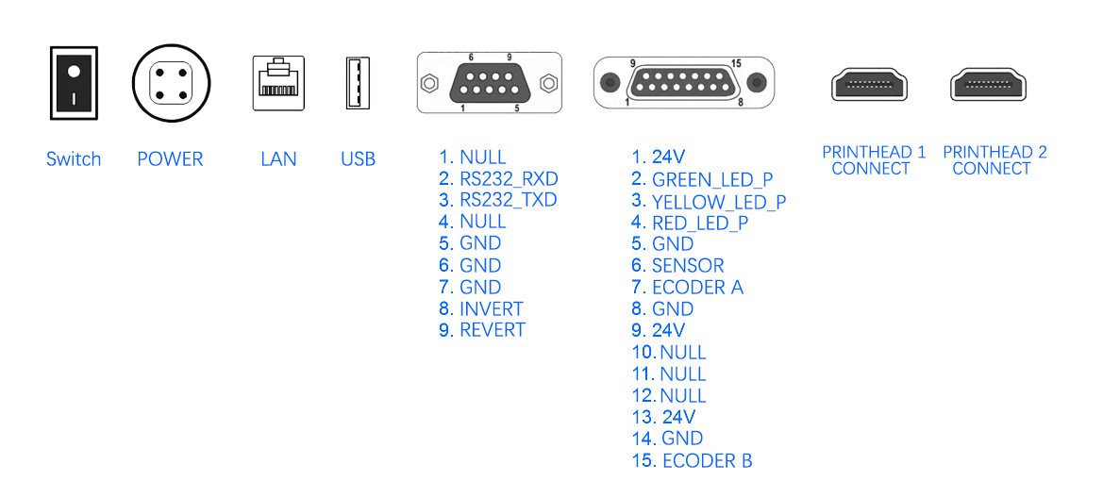

Figure 3-2 T220E Online inkjet thermal inkjet printer external interface

## 3.2 Technical specifications

|  |  |  |
| --- | --- | --- |
| **Parameter**  **Machine Type** | **T220E** | |
| **Printing parameters** | Nozzle type | TIJ 2.5 thermal foaming nozzle |
| Nozzle number | 1-2, can be matched independently |
| Printing accuracy | Maximum: 600DPI\*600DPI  Vertical optional:100DPI,150DPI,300DPI,600DPI  Horizontal optional:30-600DP |
| Print Height | Minimum 1mm / Maximum25.4mm |
| Printing distance | 1-2mm |
| Printing speed | 406m/min(90DPI)、304m/min(120DPI)、240m/min(150DPI)、120m/min(300DPI)、60m/min(600DPI) |
| Print content | Text, time, date, logo, shift, serial number, dynamic barcode/QR code, dynamic serial data, dynamic database  (Additional content can be added as required) |
| Barcode type:  CODE11,C25INTER,CODE39,EXCODE39,EAN13,EAN13x,CODE128,CODE16K,CODE49,CODE93,Flattermarken,UPCA,UPCE,EAN14,VIN,NVE18  QR code type:  QRcode,DataMatrix,MicroQRcode,PDF417,PDF417TRTRUNC,MICROPDF417  (More types can be provided on demand) |
| Printing material | Carton, plastic, metal, sheet, pipe, stone, cable, glass, electronic components, auto parts, industrial chemical packaging, medical food gift box |
| Ink type | Food grade, water-based, oily, weak solvent, solvent |
| Ink color | Black, white, red, yellow, blue, green, invisible, UV |
| cartridge chip | Contactless RFID tags for automatic identification and recording ink parameters and consumptions |
| **Machine parameters** | Operating system | Embedded Linux security operating system |
| Main hardware | Cortex-A7 1.2GHz dual-core processor/FPGA algorithm acceleration chipset |
| Communication Interface | USB、RS232、TCP/IP Network interface |
| External interface | Optical eye, Encoder, Alarm outputs |
| Nozzle installation | The nozzle is installed independently and can be matched with anti-collision components |
| Support language | Support more than 40 national languages (Chinese, English, Arabic, Danish, German, Russian, French, Finnish, Korean, Japanese, Spanish, Italian, etc.) |
| Power parameters | 30Volts 3Amps DC output |
| Machine material | Aviation grade aluminum / Industrial Stainless steel |
| Machine specifications | Controller : 192mm\*113mm\*37.6mm  Printhead group : 174.55mm\*68.1mm\*54.6mm |
| Working environment | Temperature 0-45℃/ Humidity 30-70%Rh |

# Chapter 4 Quick Start Guide

　　This chapter takes the online machine T220E as an example to introduce how to simply operate the printer,including quick operation and preparation and inspection before and after use.

## 

## 4.1 Confirm before use

|  |  |  |
| --- | --- | --- |
| SN | Items | Confirmation work |
| 1 | Inkjet printer bracket | Is the mounting bracket of the printer locked and is the production line running stable? |
| 2 | Printer location | Is the position of the printer correct, and is the nozzle surface parallel to the object being printed? |
| Is the printing distance controlled within 2-5mm? |
| 3 | Ink cartridge | Are the nozzles of the ink cartridges wiped clean, and are the RFID chips stuck to the exact position of the ink cartridges? |
| 4 | Input power | Is the input voltage of the printer normal? Is the matching adapter (charger) used? |
| 5 | Printer  information | Check the printer information, is the operating status normal, is the display interface complete, and is the screen touch effective? |
| 6 | Optical sensor | Is the installation distance of the optical sensor distance reasonable? |

## 4.2 Quick steps

|  |  |  |  |
| --- | --- | --- | --- |
| SN | Step | Explanation | |
| 1 | Install cartridges | Insert the cartridge to printer at 15 angle, and push the cartridge buckle to fix the cartridge | |
| 2 | Power on | Insert the power adapter (handheld is the charger) into the power interface of the printer; connect the controller and the nozzle with the nozzle cable, and make sure it is tight; after the printer is powered on, turn on the power switch and enter the main interface of the system. | 图片1    Figure 4-1 |
| 3 | Menu  -  Message | After the device is turned on, enter the main interface of the system, and click the "Message" button in the " Menu" column; then click the "Insert Text" button. | 1593587314(1)Figure 4-2 |
| 4 | Insert text | After clicking the "Insert Text" button, enter the printing content in the "Text " field, adjust the size and direction of the printing content and other parameters. After clicking the "OK" button, the system will return to the "Message" interface and enter the next step. | 微信图片_20200701150631  Figure 4-3 |
| 5 | Send Print  -  Start Printing | After inserting the text to be printed, click the "Send Print" button and long press the green "Start Printing" button for about 2 seconds to release, the green "Start Printing" button should change to the red "Stop Printing" display, this means has entered the printing state. | a5d583f021b9503142fb8070e068dac  Figure 4-4 |
| 6 | Stop Printing | After printing, press and hold the "Stop Printing" button for about 2 seconds to release, the red button "Stop Printing" changes to green "Start Printing" display, the device stops printing | a5d583f021b9503142fb8070e068dac  Figure 4-5 |
| 7 | Turn off the power | After stopping printing, turn off the device power switch | |

## 

## 4.3 Check after use

|  |  |  |
| --- | --- | --- |
| SN | Items | Checking work |
| 1 | Printer power | Has the printer been powered off? |
| 2 | Ink cartridge | Has the ink cartridge been removed from the print head, wiped clean and covered with the cartridge clamp?  Note: If you do not print for more than 30 minutes, please remove the ink cartridge and replace the nozzle protection cover. |

# Chapter 5 Instruction of inkjet printer

　　This chapter introduces the detailed operation of the printer, including: information editing, file management, printing/machine parameters, and service menu.

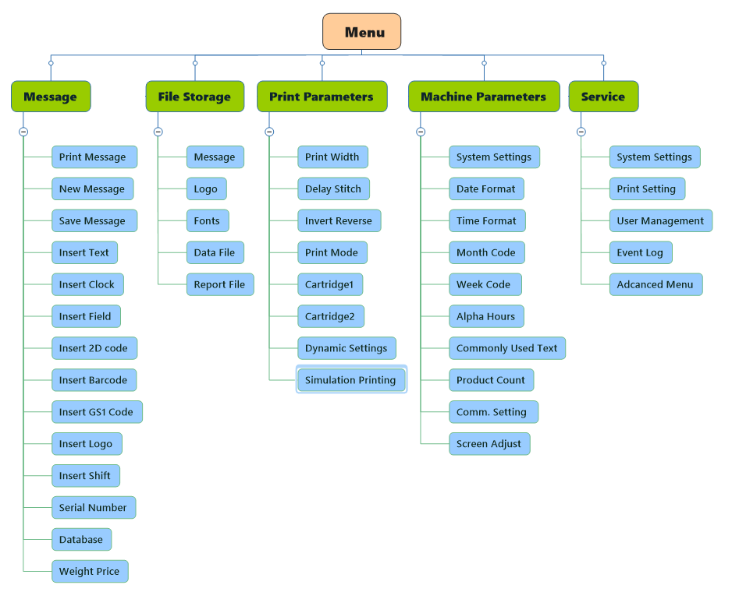

## 5.1 Main menu interface

|  |  |
| --- | --- |
| Turn on the power switch of the printer, after the device is turned on, click the "Unlock" button, the system lock interface is released, click the "Menu" button, the main menu interface pops up. (Figure 5-1) | 1593971863(1)    Figure 5-1 |
| Message | Insert, modify, edit the print content ( 5.2 for details) |
| File Storage | Management of data files, logo storage, fonts, print reports, etc. (5.3) |
| Print parameters | Printing effect setting, printing mode conversion, cartridge parameters setting and other operations (5.4 for details) |
| Machine parameters | Communication settings, system language, software update, time code and other settings ( 5.5 for details) |
| Service | Device information, user management, advanced menu and other operations (5.6 for details) |
| Homepage | After returning to the main interface of the system, it can realize functions such as count reset, serial number setting, and screen lock ( 5.1 for details) |
| Subtotal reset | Subtotal reset reset |
| SN. control | Quick control serial number |

## 5.2 Message

|  |  |
| --- | --- |
| Click the "Message" button from the main menu to enter the message editing operation interface. (As shown in figure 5-2, 5-3, 5-4)  Among them, the zoom of the editing area can be set to 5%-500% size display.  Ink cartridge capacity and unit price: the settings can be adjusted according to user needs.  Ink level: Only the cartridges with RFID can read the ink level | a5d583f021b9503142fb8070e068dac  Figure 5-2  1593972026(1)  Figure 5-3  1593972051(1)  Figure 5-4 |
| Start printing | **Need to press and hold for 2 seconds to start (Note: when the red alarm in the alarm bar, the printing cannot be started, you need to solve the alarm failure first)** |
| Print Message | Every time if the information is edited and changed, you need to click "Print Message" to update the printing content |
| New Message | Create a new message and edit the name of the message |
| Save Message | Save the current printing information to facilitate later recall. Be sure to save the edited information before creating new information. |
| Insert Text | Insert and edit the information content that users need to print |
| Insert Clock | Insert date or time in different formats for printing |
| Insert Field | Get the fields to be printed from the serial port or the scanner |
| Insert 2D code | Insert QR, DataMartix, PDF417 and other QR codes |
| Insert Barcode | Insert EAN13/14, UPCA, CODE11 and other barcodes |
| Insert Logo | Insert logo file from U disk or local device |
| Insert shift | Create shift codes in 24-hour clock system format |
| Serial Number | Create a serial numbering system and insert the system into the message |
| Database | Print the .TXT (text file, tab separated), .CSV (comma separated) or xlsx files in sequence which specified in the local or U disk file. |
| Insert GS1 code | Insert a barcode that complies with the GS1 standard |
| Weight price | Connect external equipment (such as weighing machine), insert string, weight, price data information |

### 5.2.1 Insert text

|  |  |
| --- | --- |
| **Click the "Insert Text" button to enter the text editing interface. You can insert and edit the information that the user needs to print. The user can adjust the required font size. The font size range is controlled within 5-1200 (T1 series font control range is within 5-400), which can be moved through the touch screen. The position of the text or accurate positioning through the X-axis and Y-axis positions. Note that the printing area will be incomplete if it exceeds the printing range. Click the selected text to edit the text. (Figure 5-5)** | 微信图片_20200701150631  Figure 5-5 |
| Text content | Click the text content input box, after the input method keyboard pops up, enter the information to be printed (the earth icon in the lower left corner of the keyboard, click to switch the input method) |
| Common text | Call commonly used information text (see step 5.5.5 for details) |
| Copy | Copy the text information in the current text edit box |
| X, Y axis position | The position of the text can be moved through the touch screen or accurately positioned through the X-axis and Y-axis positions. |
| Direction | Set font orientation (90 degree, 180 degree, 270 degree rotation) |
| Font Size | Set the font size (the setting range is 5～1200) |
| Font | Choose different fonts according to your needs, the choice is the installed font |
| Space | Adjust the spacing between fonts in the text (-30 ~ 30), the greater the value, the greater the spacing |

### 

### 5.2.2 Insert clock

|  |  |
| --- | --- |
| Click the "Insert Clock" button to insert the date or clock in the message. The format and offset value of the clock or date can be set from the options, and the date/time format can be edited, added, or deleted as needed. (Figure 5-6) | 微信图片_20200701151039Figure 5-6 |
| Clock content | Choose to insert date or clock information |
| Date format | Choose the format of the date, you can choose yyyyMMdd, yyMMdd, ddMMyyyy, ddMMyy and other formats, or you can edit and add the format according to your needs (see 5.5.2) |
| Time format | Select the format of time, you can set the format of hh: mm: ss, hh: mm, hhmmss, mmss, ss, etc., or you can edit and add it according to your needs (see 5.5.3 for details) |
| Clock offset | The user can set a certain clock offset and print a clock. The clock is a clock (date) derived from the main clock (machine time). The date offset is accurate to the hour to meet the production date update in advance. |
| **Note: The clock offset function can print the time before the main time of the machine, and can also print the time after the main time. The time before the main time of the printing system can be effective by adding a "-" before the variable. (This function is commonly used for printing food, fresh and other products)** | |
| More Properties | The position, font, direction, spacing and other settings of the information on the X and Y axes (see introduction in 5.2.1 Insert text) |
| Function key options | **Cancel** Return to the previous menu. |

### 5.2.3 Insert field

|  |  |
| --- | --- |
| Click "Insert Field" to insert field information in the message. Field printing is achieved through externally acquired field information.  When you click "Data Source" to select the scanner as the field source, click the "Add Field" button, a field displayed as "Field0" will appear in the screen print editing area, continue to click the "Add Field" button, and the number of inserted fields will be constantly increasing; the operation is the same when selecting the serial port in the "Data source". However, the inserted blank field is displayed as "NULL", when the serial port has sent data, the data content will be displayed. | 微信图片_20200701151043Figure 5-7 |
| Data source | The field source can be selected from the scanner or from the serial port |
| Field length | The length of the field display |
| Field ID | When serial source is selected as serial port, serial number of serial data field is selected |
| Current field | Display current field content |
| Character set | Ascii uses pre-generated ascii fonts for printing. The advantage of this method is faster speed; unicode can type characters that contain Chinese or other non-ascii codes. The disadvantage is that it can't play that fast speed. |
| Alignment | Choice of left or right alignment |
| Add field | Add multiple fields (one field is shown in Figure 7) |
| Update field | After clicking Update Field, scan the code with a scanner to get a new field. This function is only valid when the source of the field is a scanner |
| Function key options | **Cancel** Insert fields without going in, return to the previous menu |
| Other attributes | **OK** insert the field information in the message |

### 5.2.4 Insert 2D code

|  |  |
| --- | --- |
| Click "Insert 2D code" to select QRcode or DataMatrix code and other 2D codes in the code type and insert it in the text information. Edit the information in the inserted content to generate the corresponding QRcode code or DataMatrix and other 2D codes. | 微信图片_20200701151051Figure 5-8 |
| Code type | Choose QRcode, DataMatrix, MicroQRcode, PDF417, PDF417TRUNC, MICROPDF417 codes. |
| Insert | Insert text, time, serial number, shift, file, serial port data and other information content. If you need a QR code such as WeChat or website, you can also enter the content through the QR code. |
| **Note: Two-dimensional code, bar code can insert multiple text, time, serial number, shift and other information, but only one database can be loaded** | |
| X, Y axis | The position of the text can be moved through the touch screen or accurately positioned through the X-axis and Y-axis positions. |
| Size | Scale on the basis of the original image, not custom height and width to scale |
| Tolerance | Refers to the ability of the two-dimensional code to be blocked, and it can still be scanned. The higher the fault tolerance rate, the more the two-dimensional code can be blocked. The fault tolerance level is divided into: L, M, Q, H. (H is the highest level of error tolerance, and the greater the ability of the QR code to be scanned out if you select H) |
| Other attributes | **Direction**: Set the direction of the two-dimensional code (90 degree, 180 degree, 270 degree rotation). |
| **Frame**: You can choose two modes of upper and lower borders and surrounding borders |
| **Inverse**: Contrast color with the color inserted into the QR code. |
| **Frame size**: the size of the red frame outside the QR code. |
| Function key options | **Cancel** Return to the previous menu. |
| **OK** Insert the QR code in the message. |
| **Delete** Delete the QR code information. |
| **Copy** Copy the QR code. |

### 5.2.5 Insert Barcode

|  |  |
| --- | --- |
| You can select EAN13/13x/14 code, CODE11/128/16K/49/93 code or UPCA/E code in the bar code type and insert it in the text information, edit the information in the inserted content to generate the corresponding EAN13/13x /14, CODE11/128/16K/49/93 or UPCA/E and other codes | 微信图片_20200701151054  Figure 5-9 |
| Code type | EAN13/13x/14 codes, CODE11/39/128/16K/49/93 codes |
| X, Y axis | UPCA/E,EXCODE39,Flattermarken,VIN, NVE18 and other codes |
| Inserts | The position of the text can be moved through the touch screen or accurately positioned through the X-axis and Y-axis positions. |
| Size | Scale on the basis of the original image, not custom height and width to scale |
| Barcode height | Adjust the height of the bar code from 0 to 64 |
| More Properties | **Direction:** Set the direction of the bar code (90 degree, 180 degree, 270 degree rotation). |
| **Frame**: You can choose two modes of upper and lower borders and surrounding borders |
| **Frame size**: the red frame size outside the barcode. |
| **Inverse:** contrast with the color of the inserted barcode. |
| **Text:** whether the text below the barcode is hidden |
| Function key options | **Cancel** Return to the previous menu without entering the barcode.  **OK** Enter the barcode in the message.  **Delete** Delete the barcode information.  **Copy** Copybar code |

### 

### 5.2.6 Insert Logo

|  |  |
| --- | --- |
| Click the "Insert logo" button to select a logo in the logo memory and insert it in the text message. Note that the red frame will appear in the editing area beyond the printing range;  The format of the inserted picture only supports .bmp format, and the size of the inserted picture should not exceed 4MB. | 微信图片_20200701151057  Figure 5-10 |
| File Source | The triangle sliding menu has two options including local files and U disk files. |
| Select File | Find the corresponding picture name in the local file or U disk file and insert the picture. |
| Scaling ratio | Scale on the basis of the original image, not custom height and width to scale |
| Inverse | Contrast with the color of the inserted logo. |
| Height | Insert the height of the picture. |
| Width | Insert the width of the picture. |
| Direction | Set the orientation of the picture (90 degree, 180 degree, 270 degree rotation). |
| X, Y axis | You can move the position of the picture through the touch screen or accurately position it through the X-axis and Y-axis positions. |
| Copy | Copy selected logo |
| Function key options | **Cancel** Return to the previous menu without inserting a logo.  **OK** Insert the logo in the message.  **Delete** Delete the logo information. |

### 5.2.7 Insert Shift

|  |  |
| --- | --- |
| Click the "Insert Shift" button to create shift code information and increase or decrease the shift. Up to 6 shifts can be added. There should be no time overlap between adjacent shifts. | 微信图片_20200701151100  Figure 5-11 |
| Shift code | The shift code can be entered according to user needs. (Example: AAA) |
| Starting time | Enter the hour and minute of the start time in the format of a 24-hour clock system. |
| End Time | Enter the hour and minute of the start time in the format of a 24-hour clock system. |
| Add Shift | More shifts can be derived from the created shift codes。 |
| **Note: In the inserted shifts, the time between adjacent shifts cannot overlap** | |
| Remove Shift | Delete the derived shifts. |
| More properties | Insert shift font, direction, spacing format settings. |
| Function key options | **Cancel** Return to previous menu without inserting shift  **OK** Insert the shift in the message.  **Delete** Delete the shift information.  **Copy**  Copyshift |

### 5.2.8 Serial number

|  |  |
| --- | --- |
| Click the "Serial Number" button to create a serial number. The system inserts the serial number into the information. The serial number with the limit value 1 less than the limit value 2 will increase in sequence, otherwise it will decrease. The serial number control page can enter the serial number control interface by clicking the "SN Control" button at the bottom of the figure (or by clicking " Homepage" in the "Menu" and clicking the "SN Control" button on the homepage). | 微信图片_20200701151103  Figure 5-12 |
| Serial Number | Number the created serial number. Both T1 and T2 series models support the editing of 24 serial numbers. |
| Leading 0 | Whether to add zero in front of the serial number, you can choose yes or no. |
| Serial number control | **Limit 1**: The starting value of the serial number.  **Limit 2**: The end value of the serial number.  **Setting step**: the difference between adjacent numbers.  **Repeat:** The number of times the sequence number being printed is repeated before the next sequence number is printed.  **Current Repeat:** The number of times the current serial number is printed repeatedly |
| Serial number control | **Cancel** Return to the previous menu without inserting a serial number.  **OK** Insert the serial number in the message.  **Delete** Delete the serial number information. |
| Function key options | **Cancel** to the previous level without inserting the serial number  **OK**  Insert the serial number in the message.  **Delete**  Delete the serial number information.  **Copy**  copy SN number |

### 

### 5.2.9 Database

|  |  |
| --- | --- |
| Click the "Database" button to enter the interface shown in Figure 5-13. Click "Select File" to choose the .TXT (text file, tab separated) or .CSV (comma separated) file specified in the local or U disk file. The lines are printed sequentially or repeatedly.  **Note: Files that are not in .TXT (text file, tab separated) or .CSV (comma separated) format will not be recognized by the machine.** | 微信图片_20200701151106Figure 5-13 |
| Select File | Find the corresponding file name in the local file or U disk file to insert the file. |
| Current Line | The number of lines currently printed. Note that the number of lines cannot exceed the total number of items. |
| Total Line | The total number of rows in the current print column. |
| Total Row | The total number of columns in the current variable. |
| Start line | The current print column starts printing from that line. Note that the number of lines cannot exceed the total number of lines. |
| End line | The current print column ends printing from that line. Note that the number of lines cannot exceed the total number of lines. |
| Repeat | Set the number of repeated prints current line |
| **Note: The number of repeated prints refers to the number of repeated prints on the current line** | |
| Loop printing | The number of times the variable being printed is printed repeatedly before starting to print the next variable. |
| **Note: the cyclic printing yes or no is for the total target print line** | |
| Function key options | **Cancel** to the previous menu without entering the insert database file  **Delete** delete file information |

### 5.2.10 Insert GS1 code

|  |  |
| --- | --- |
| Click the "Insert GS1 code" button to enter the operation interface in Figure 5-14. Click the "Identifier" data option bar. You can choose to insert the four data of GTIN, BATCH, PRO, and SN. You can also add or select data in the database perform identifier insertion. As Figure 5-15 shown.        Example: Select to insert "GTIN", the "Content" column will display the inserted "GTIN" name, "Identifier", "Keyword" and other equivalent systems will be automatically generated, select "Data Source" to select the inserted data From serial port or customized (Note: When "Customize" is selected, the "Data ID" is turned off and the data is manually entered in the "data" edit area). As Figure 5-14 shown.    After editing and inserting the required identifier, click the "OK" button, the system enters the figure interface; click: "DM code", click the identifier name button that needs to display the DM code in the "GS1 code options" column, the display code will do If there is a change, adjust the size, position and size of the DM code, etc., click Confirm, and the DM code will be completed. If you need to display the DM visible code, click the "Visible Code" button, and then click the identifier option that needs to be visible. The identifier content will appear on the right side of the DM code. Adjust the size and position of the print content to print. | 微信图片_20200701151109微信图片_20200701151111  图5-15  Figure 5-14  微信图片_20200701151114  Figure 5-16  Figure 5-15 |
| Insert | You can choose to insert identifiers such as GTIN, EXP, BATCH, PRO, SN, etc., or you can choose to insert "new" or "database". |
| Content | After selecting the inserted identifier, " Content" will display the name of the inserted identifier. |
| Identifier | The serial number of the specific identifier cannot be changed, and the system automatically generates it after selecting the identifier. |
| Keyword | You can change the keyword of the identifier, and the display of the identifier will also change accordingly. |
| Data Sources | Choose from Serial data or customize |
| Function key options | **Cancel** Cancel to the previous menu  **OK** Confirm parameter setting  **Delete** Delete file information |
| **Note: Whether the edited GS1 code can be scanned out depends on whether the GS1 code is officially authorized.** | |

### 5.2.11 Weight price

|  |  |
| --- | --- |
| The use of this function requires a weighing machine to be connected. Click the "weight price" button, the system will generate a blank field on the screen. After setting the data ID and connecting the weighing machine, select "Weight" or "Price" in the "Data Type", and the data sent from the weighing receiver will be automatically received and displayed in the blank field frame; if "Price" is selected, The system will display the price value according to the setting of the "unit price" number (price = weight\*unit price). As shown in Figure 5-17 | 微信图片_20200701151122Figure 5-17 |
| Data ID | ID number of the data at the sending end of the weighing machine |
| Length | Print the displayed data length |
| Font size | Set the font size for display (printing) |
| Font | Select the font type for display (printing) |
| Spacing | Spacing between data values |
| Data Type | Optional character string, weight, unit price |
| Coefficient | Displayed when the data type is "weight" |
| Price | Appears when the data type is "Price" |
| Prefix | Insert a prefix for data |
| Suffix | Insert a suffix for data |
| More Properties | Click "Other Properties" to display the location and orientation of the data |
| Function key options | **Cancel** Cancel to the previous menu  **OK**  Confirm Data file  **Delete** Delete file information  **Copy** Copy current information |

## 5.3 File Storage

|  |  |
| --- | --- |
| After clicking the "MENU" button, enter the "File Storage" interface, as shown in the figure.  In the file storage, you can manage the information, logos, fonts, and data of the printer. All files can be imported and exported from external U disks to external U disks. The information file format supports .msg, the logo file format supports .bmp, the font file format supports .ttf/.ttc/.otf, the data file supports .txt/.xlsx/.csv format, and the printer contains 256MB of storage space. | 微信图片_20200701152343Figure 5-18 |

### 5.3.1 Message

|  |  |
| --- | --- |
| Click the "Message" button to enter the interface shown in Figure 5-19. The interface will display a list of local information files of the printer, including the file name, the modification time of the file and the size of the information file. The information files stored in the printer can be edited and managed. | 微信图片_20200701152356Figure 5-19 |
| Select File | After selecting the information to be printed, click the "Select File" button, and the selected information will appear on the printing screen. Note: Only one file can be selected at a time. |
| Function key options | **Return** to the previous menu without entering the information storage.  **Delete** After selecting the information to be deleted, click "Delete" to delete the selected information. You can delete multiple files at a time.  **Import** After inserting USB into the corresponding interface of the printer, the information content in the USB device can be imported into the printer.  **Export** After inserting USB into the corresponding interface of the printer, you can export the information content in the printer to the USB device. |
| **Note: a. The bottom function keys "Delete", "Import" and "Export" must first select the file (click the "Select" column, the white box after the information line in the middle)**  **b.Message files between different models or models with different versions cannot be imported and recognized from each other** | |

### 5.3.2 Logo

|  |  |
| --- | --- |
| Click the "Logo" button to enter the interface shown in Figure 5-20. The interface will display a list of the local logo files of the printer, including the file name, the modification time of the file and the size of the logo file. | 微信图片_20200701152359Figure 5-20 |
| **Note: a. The printer only supports bmp. format logos, and T1 (T2) series models support a maximum of 150dpi (300dpi) logos**  **b. For function key options, refer to 5.3.1 Information Storage Instructions.** | |

### 5.3.3 Fonts

|  |  |
| --- | --- |
| Click the "Font" button to enter the interface shown in Figure 5-21. The interface will display a list of local font files of the printer, including the file name, the modification time of the file and the size of the logo file.  Click the small white box below the "Selected" column to select the list font. | 微信图片_20200701152401Figure 5-21 |
| Install | Click the "Install" button, the system interface will display a list of fonts available for machine installation; if the font file has been selected, a black checkmark will be displayed in the font selection column.  　 After checking the font files you want to install, click the "OK" button, the system will prompt that the newly installed fonts need to restart the printer to take effect; click the "OK" button to restart the printer, the new font installation is complete. For details, please refer to 5.2.1 " Font". |
| **Note: a. It takes a certain amount of time to install fonts. When the number of installed fonts is large, the waiting time for installation may be longer. Please do not operate the machine during this process.**  **b. After the font is installed, you must restart the printer to take effect, or you can not select the installed font**  **c. For function key options, refer to the description in 5.3.1 Message** | |

### 5.3.4 Data file

|  |  |
| --- | --- |
| Click the "Data File" button to enter the interface shown in Figure 5-22. The interface will display a list of the printer's local database files, including the file name, file modification time, and logo file size.  The database file imported into the local printer can be called and used in the "Select File" button in 5.2.9 "Database". | 微信图片_20200701152403Figure 5-22 |

### 5.3.5 Report file

|  |  |
| --- | --- |
| Click the "Report File" button to enter the interface shown in Figure 5-23. The interface will display a list of the printer's local database files, including the file name, file modification time, and logo file size.  The print report stored in the "Report File" is the print record generated when the printer is connected to an external device. The report will be generated only when the "Print Report" function in the "Communication Settings" is turned on. For details, check **5.5.7** | 微信图片_20200701152406Figure 5-23 |

## 5.4 Print parameters

|  |  |
| --- | --- |
| In the printing parameters of the main menu, you can adjust the printing parameters of all the information in the printer. The printing parameters are common settings and are valid for all information. The main interface of the printing parameters will display the information of the printing parameters after the current printer adjustment. | 微信图片_20200701170914Figure 5-24 |
| **Note: Total printing delay = Print delay(customer setting delay) + system minimum printing delay (minimum printing delay can be set in the service menu)** | |

### 5.4.1 Print width

|  |  |
| --- | --- |
| Click "Print Width" to enter the interface shown in Figure 5-25. The parameter settings of this interface will directly affect the printing effect.  When the synchronization mode of the equipment production line is set to "external encoder"; if the encoder pulse sampling is "Infinite frequency ", the parameters in the green box in the figure cannot be modified. If the encoder pulse sampling is "Crossover mode", the parameters in the "encoder divider ratio" in the green frame can be modified.  When the synchronization mode of the equipment production line is set to "internal fixed speed"; the "internal fixed speed" parameter can change the value, and the encoder parameter options will be locked and cannot be edited.  **Horizontal resolution set:** 40-2400dpi can be set  **Vertical resolution set:** as shown in Figure 5-26  **Note: Changing the horizontal resolution will affect the printing speed, while changing the vertical resolution has no effect on the speed.** | 1593972682(1)微信图片_20200701170927Figure 5-25  **The left and right rows of nozzles work at the same time, which is twice as fast as the single row printing**  **The left and right columns print the same content at the same time through delay; while increasing the grayscale, they can maintain high-speed printing.**  **Single row 1/2, 1/3 Use one-half or one-third ink hole of a row of nozzles to print ink**  Figure 5-26 |
| Light eye effective pulse width | The optical eye is interfered by external information, and sometimes an unstable pulse signal is transmitted to the machine. At this time, increasing the effective pulse width of the optical eye can play a role in filtering and shielding the interference signal pulse. |
| Trigger Level | Can be set to high or low level, combined with "current level" and "Line speed" can be a good detection of whether the light eye is in a normal working state (Note: the setting of the effective level value will affect the position of printing ) |
| Refresh | Press the "Refresh" button to display the current production line speed |

### 5.4.2 Delay stitch

|  |  |
| --- | --- |
| Click the "Delay Stitch" button to enter the interface shown in Figure 5-27. Under this interface, single cartridge printing, double cartridge independent printing, and double cartridge stitched printing function can be realized; some print delay parameter settings are set for the above three printing modes to debug the printing effect. | 微信图片_20200701170931Figure 5-27 |
| Single Cart. | Use only one print head for printing |
| Double Cart. (independent) | The printing content of each nozzle is independent of each other and does not interfere with each other |
| Double nozzle (Stitched) | Two print heads splicing and printing the printing information |
| Print delay | The distance from the sensor to the product to the beginning of printing, which is convenient for customers to adjust the position of the printing content on the product. |
| Cartridge1/2 Product remaining length | Avoid multiple signals on the same product interfering with printing,the cartridge does not receive the optical eye signal within a certain length |
| **Note: a. When printing with a single cartridge, only cartridge 1 is effective, cartridge 2 does not work**  **b. When double cartridges are spliced, the vertical splicing can realize the seamless splicing in the vertical direction by adjusting the number of ink dots of the “Cartridge 1-2 overlap”; the horizontal splicing can realize the seamless splicing in the horizontal direction by the “Cartridge 1/2 print delay”**  **c. If the cartridge 1-2 overlap is set to 0, the vertical direction still cannot be seamlessly spliced, you need to adjust the angle of the cartridge group** | |

### 5.4.3 Invert Reverse

|  |  |
| --- | --- |
| Click the "Invert Reverse" button to enter the interface shown in Figure 5-28. You can flip or reverse each message. Unless dynamic control is used, this option will apply to all messages. If you use dynamic control, you can set the number of times to reverse or reverse printing. | 微信图片_20200701170937Figure 5-28 |
| Cartridge Reverse Control | It can be turned on or off, and it is common to all information. |
| Cartridge Inverse Control | It can be turned on or off, and it is common to all information. |
| Function key options | **Cancel** Discard the changes and return to the previous menu. |

### 5.4.4 Print Mode

|  |  |
| --- | --- |
| Click the "Print Mode" button to enter the display interface in Figure 5-29. Under normal circumstances, the machine's default factory printing mode is "standard mode". In this mode, the printer will always print the print content displayed on the home page and sent. No special printing requirements, no need to change the printing mode.  　After clicking the "Standard Mode" button in this interface, the print mode options available for switching will pop up. | 微信图片_20200701170940Figure 5-29 |
| Select "Continuous" printing mode, the printer will print the same information continuously after receiving a signal to trigger printing. By setting the interval value (mm) of continuous printing, the equidistant continuous printing of information is realized.  The default setting of "Update Numbers each Repeat" is "Yes" (Note: You can choose Yes or No. If you select Yes, the variable will be updated at the same time every time you print repeatedly, otherwise it will not be updated.)  The default setting of "Last Message Print All" is "Yes" | 微信图片_20200701170945Figure 5-30 |
| Select the "Counting" printing mode, the printer will complete the set number of times of printing according to the set "count the number of print" value. Same as "Continuous Mode", you can also set the printing interval of printing information (click the "Repeat Pitch" button to set)  The default setting of "Update Numbers each Repeat" is "Yes"  The default setting of "Use Product End" is "Yes"  (Note: Use Yes/No to select whether to stop repeating when the end of the product is detected.) | 微信图片_20200701170948Figure 5-31 |
| Select "Grouping" printing mode, the printer will print the information in the "Grouping File" list.  Click the "Increase Files" button, the system internal information file list pops up, by checking and unchecking, to realize the increase and decrease of the "group file" printing information list. When printing, you can also set the "Extra Delay" value to compensate for the delay of the corresponding information. | 微信图片_20200701170951Figure 5-32 |
| **Note: a. If the information switching mode is "Cycle Switching", the printer will switch the printing information among all the selected information.**  **b. If the information switching mode is selected as "external control", the level combination of the external information selection input pin will switch the corresponding printing information. (This method switches the information during photon detection. It takes a certain time to switch the information, so this method must increase the print delay setting appropriately)** | |
| Select the "Counting grouping" printing mode, the printer will print the group files added in sequence according to the set printing interval after each trigger of the optical eye.  This mode is a combination of "counting mode" and "grouping mode". The grouping file is switched during the count printing process. The counting grouping mode can set different printing intervals for different files (similar to the additional printing interval of the grouping mode) | 微信图片_20200701170953Figure 5-33 |
| **Note: The "print interval" in the counting grouping mode does not know the length of the file to be counted and the group prints, so the machine cannot automatically correct this value, so when setting the print interval, the print interval should not be less than the "Message length"+the length to switch file" corresponds to the distance the production line travels during this time, and the customer needs to make his own judgment.** | |

### 5.4.5 Cartridge parameter

|  |  |
| --- | --- |
| Click the"Cartridge Parameter" button in the "Print Parameters" to enter the interface shown in Figure 5-34. The settings interface provides general information about ink cartridge settings. | 微信图片_20200701170956Figure 5-34 |
| Column Selection | You can choose the left or right column of nozzles to print, or you can choose the "Alternating" of alternating inkjets from the left and right column.  **Note: "Alternate mode" means that for each message printed, the nozzles in the left and right columns of the ink cartridge are switched in sequence.The delay compensation is determined by the double-row spacing parameter.** |
| Nozzle space(um) | **The distance between the left and right columns of the nozzle can determine the delay compensation of the "alternating mode"** |
| Cartridge Parameters | You can choose automatic setting, manual setting, water-based ink preset and solvent ink preset. |
| **Note: a. Automatically set the ink cartridge for the cartridge with RFID chip attached, or you can manually set the print pulse width and nozzle voltage according to the cartridge parameters.**  **b. "Water-based/solvent ink preset" is the default setting according to the standard HP ink cartridge parameters, please set manually for special parameters** | |
| Print Pulse | In "Manual mode", it can be adjusted manually according to the ink cartridge parameter information, and cannot be changed in other settings. |
| Nozzle Voltage |
| Product Direction | Choice left or right |
| **Note: a. The Product direction of the nozzle is viewed from the front of the nozzle, the direction that the product approaches**  **b. In alternating mode and double-row high-speed mode(eg.300dpi High Speed), this parameter must be set accurately** | |
| Preheat setting | choose off/60℃/65℃/70℃/75℃/80℃. |
| **Note: This function is "Off" by default, customers can turn on this function in low temperature working environment** | |
| Flash Jet Set | Off/1min/5min/10min/20min/30min/40min/50min/60min, nozzle flashes ink to keep the nozzle moist and prevent nozzle clogging |
| Flash Jet Columns | Set number of columns to flash print |
| Grayscale settings | 1-6 level, the higher the level choose, the darker the printed color. |
| **Note: Increasing the printing grayscale will reduce the printing speed** | |
| Determine to all | Single cartridge setting confirms all cartridges |
| Cleaning nozzles | Long press is effective, can be used to clean the nozzle, check whether the nozzle is blocked, pay attention to block the nozzle |
| Function key options | **Cancel** Discard the changes and return to the previous menu. |

### 5.4.6 Dynamic Settings

|  |  |
| --- | --- |
| Click the "Dynamic Settings" button to enter the interface shown in Figure 5-35. You can set a certain information to be inversed or reversed to print control mode.  Reverse/Inverse dynamic control: Off, information control, product control, external control. | 微信图片_20200701170959Figure 5-35 |
| Message control | Inverse/reverse each time the information is printed |
| Product control | Every time a product is detected, it is inversed/reversed |
| External control | The level of the external control input determines whether to reverse or inverse |
| Function key options | **Cancel** Discard the changes and return to the previous menu. |

### 5.4.7 Simulate Printing

|  |  |
| --- | --- |
| Click the "Simulate Printing" button to enter the interface shown in Figure 5-36. The inkjet printer can realize simulated printing under the state of starting printing (Without optical eyes, it can be printed once time)  **Note: This function can be used as the detection of sensor function** | 1593973083(1)Figure 5-36 |

## 5.5 Machine parameters

|  |  |
| --- | --- |
| It is used to modify the parameter format of the printer, and can adjust the mechanical parameters of all the information in the printer. The mechanical parameters are universal settings and are valid for all information. The main interface of the mechanical parameters will display the current printer cartridge model, ink margin, information such as batch, drive voltage, and print pulse width etc. | 9b3cc81a87d5f8fc7314140525b0eecFigure 5-37 |
| **Note: a. The ink cartridge information only shows the ink cartridge with the RFID chip attached. The information cannot be displayed for the ink cartridge without the RFID chip attached.**  **b. Since only one ink cartridge is installed in the T1 series printer, only the information of a single ink cartridge is displayed.** | |

### 5.5.1 System settings

|  |  |
| --- | --- |
| Click the "System Settings" button to enter the interface shown in Figure 5-38. This interface can change the system language (requires restart to take effect) and the input method language; Set the time for screen saver.  The reverse switch of the screen brings convenience to the actual installation; the switch setting of various sounds and the system clock (machine time) | f0906dd6fa9a568d6a66b5c3d339b7bFigure 5-38 |
| System language | One of 21 languages can be selected as the system language |
| **Note: After selecting a language as the system operation language, click the "OK" button, the system will prompt whether to restart the device, and the new language will take effect after restarting.** | |
| Input method language | One of 21 input methods can be selected as the keyboard input method |
| Screen Saver | Set the screen saver switch, can be set for 1-60 minutes |
| Screen upside down | 180 degree upside down screen, easy to install and use from multiple angles |
| **Note: To turn on the "Screen upside down" function, after clicking the "OK" button, the system will prompt whether to restart the device, and the screen reversal will take effect after restart.** | |
| Beeper | Keyboard sound switch |
| Print trigger sound | After the sensor detects the product, it triggers the printing tone switch |
| Print End Sound Alarm | Prompt tone switch at the end of printing |
| Master Clock | Machine master time |
| Function key options | **Cancel** Cancel to previous level menu |

### 5.5.2 Date format

|  |  |
| --- | --- |
| Click the "Date Format" button to enter the interface shown in Figure 5-39. This interface can add, supplement or delete the date format in the memory. Up to 15 date formats can be added and retained; the new date format can be used in "Insert Clock" under "Message".(check 5.2.2 for details) | 429d52279088ad45898e9981dee664fFigure 5-39 |
| Create New Form | Choose to create a new date format in the year variable/month variable/week variable/day variable/separator, and click the "<<" symbol button to delete the variable. After editing the new date format, click the "Add" button and then click "OK" below to create a new date format. |
| Function key options | **Cancel** Return to the previous menu.　　**OK** to add new format and return to the previous level  **Delete** Delete the selected date format. |
| **Note: a. After creating a new date format each time, be sure to click the "Add" button and then click the "OK" button, otherwise it will not take effect; the newly added date format can be inserted into the "Insert Clock" under "Message" be called;**  **b. Currently, the maximum number of date formats that can be added by the system is only 15. If you need to add other date formats, you need to delete the previously stored date format and add it.**  **c. Click the "MCODE" button to insert the month code; click "WCODE" to insert the week code; click "WN" to insert the week number.** | |

### 5.5.3 Time format

|  |  |
| --- | --- |
| Click the "Time Format" button to enter the interface shown in Figure 5-40, which can add, supplement or delete the time format in the memory. Up to 15 date formats can be added and retained; the new date format can be used in "Insert Clock" under "Information Editing". (check 5.2.2 for details) | c1a7b026f6dcabc694dbe15d001b174Figure 5-40 |
| Create New format | In the hour variable/minute variable/second variable/separator, select to create a new clock format, click the two less-than signs to delete the variable, edit the new time format and click Add to create a new time format. |
| Function key options | **Cancel** Return to the previous menu. |
| **Note: a. Each time a new time format is created, be sure to click the "Add" button and then click the "OK" button to take effect; the newly added date format can only be inserted under "Information Edit" Called in the "clock" function**  **b. Currently, the maximum number of date formats that can be added by the system is only 15. If other date formats need to be added, delete the previously stored date format and add it.** | |

### 5.5.4 Base format

|  |  |
| --- | --- |
| Click the "Base Format" button to enter the interface shown in Figure 5-41, which allows you to add or delete hexadecimal formats in the memory. The new base format can be used in "Insert Clock", "Insert Serial Number" and "Insert Random Number" under "Information Editing". (See 5.2.2 for details) | E:/6.图片/TIJ/5-41.png5-41图5-41 |
| Base name | Customize the name of the new hexadecimal system. |
| Carry system | Display the base type. |
| Numerical value | Customize the input value, each character is an element symbol. The total number of elements is the carry system. Such as the value "0123456789". The characters '0', '1'... are the 0th element, the 1st element,... respectively. There are ten elements in total from 0 to 9, so the carry system is 10. This is every tenth day. |
| Function key options | Return Return to the previous menu.  OK Add new base format and return to the previous menu.  Delete Delete the hexadecimal format in the memory. |
| **Note: a. Every time you create a new hexadecimal format, you must click the "Add" button and then click the "OK" button to take effect; the newly added hexadecimal format can only be added under "Information Editing" Called in the "Insert Clock", "Insert Serial Number" and "Insert Random Number" functions** | |

### 5.5.5 Month, week, hour code

|  |  |
| --- | --- |
| Click the "Month Code" button to enter Figure 5-42. The month name can be modified to be used when inserting the clock function when editing information.  　　January, February...December: Enter up to 3 numeric or alphabetic characters. | c5bb6de12424585b4f5b3280b93006bFigure 5-42 |
| Click on the "Week code" button to enter Figure 5-43, you can modify the name of the week for the use of the clock function when editing information.  　　 Monday, Tuesday...Friday: Enter up to 3 numeric or alphabetic characters. | 19d53ade66075943d5667122c4cc194Figure 5-43 |
| Click the "Alpha hour" button to enter Figure 5-44. You can associate an alphanumeric character with each 24-hour period. You can use the insert clock to insert these characters in the message.  　　 0 o'clock, 1 o'clock ... 23 o'clock: Enter up to 3 numeric or alphabetic characters. | afd7087094a4f21f4cd3ac12e635f3cFigure 5-44 |
| Save as default | Keep the new name for new information. |
| **Note: Saving the default value is the setting saved by the user according to personal needs. If you choose to save as the default attribute, you do not need to reset it after each time system start up** | |
| Use default value | Use the default name in the message. |
| Function key options | **Cancel** Discard changes  **OK**  Confirm change |

### 5.5.5 Common texts

|  |  |
| --- | --- |
| Click the "Common Texts" button to enter the interface shown in Figure 5-45. After clicking the text input box next to "Create New Format", the input keyboard pops up, enter frequently used text information, and click the "Add" button. The newly created common text will appear in the default three common below the text. This common text can be called up in the "**Insert Text**" function in the **Message** menu (check 5.2.1 for details) | aab2a0ad2db457069dc2d5a21dd73d4Figure 5-45 |
| **Note: a. Common text can be added up to 18 items**  **b. After adding the required common text items, be sure to click the "OK" button at the bottom, otherwise it will not be saved and take effect** | |

### 5.5.6 Product count

|  |  |
| --- | --- |
| Click the "Product Count" button, you can view the current number of detections and prints and the total number of detections and total prints of the printer in the product count; at the same time, the reset time is displayed in the subtotal and total columns, so that customers can easily Print statistics. | 742ce65d4126dff35583a7105287dbcFigure 5-46 |
| Product count | Product testing and counting |
| Print count | Print detection count |
| Reset time | The reset time of the subtotal reset and total reset are independent of each other, but after the total reset, the subtotal reset time changes simultaneously |
| Counting Method | **Off: turn off the counting pulse output function**  **Print count:** When the number of printed products reaches the set value, it can output a signal to an external device  **Product count:** When the detected product number reaches the set value, it can output a signal to an external device |
| output method | **Pulse output:** After the product or print count reaches the set value, it is output as a pulse signal to an external device  **Level output:** After the product or print count reaches the set value, it is output to an external device as a level signal |
| **Note: The counting pulse output function T1 series equipment is not supported temporarily** | |

### 5.5.7 Communication settings

|  |  |
| --- | --- |
| Click the "Communication Settings" button to enter the interface shown in Figure 5-47. The left part is the cache setting during communication, and the right part is the communication protocol setting.  Connect the printer to an external machine (PC, PLC, weighing machine, etc.) by checking the protocol. The external information can be selected whether to display the cache in the printer interface.  There are two main ways to connect external devices: serial RS232 connection and network port IP connection. | c5d00aec13ab9c3f82f498452c87959Figure 5-47 |
| RS232 Settings | de3ef93016ae488d9c6b1199d193ea3  Figure 5-48  Match the Baud rate and other data of the external machine to the printer and complete the connection |
| Ethernet settings | de2fecbadd190fc76fbc0a3c54d7dd6  Figure 5-49  Set the IP address to be the same as the computer address, and realize the data transmission through the software. (T1 series is not supported yet) |
| Buffer settings | **Number :** 1-10 buffered data can be selected  **Display:** Choose whether to display the cache content (10 cache bits will be displayed after opening, but the actual number of cached display is determined by the "cache number" setting)  **Filled Up:** You can choose whether to continue to accept data cache after the cache is full  **Clear:** Click to clear the cached content |
| Printer settings | **Protocol:** In the factory state, the machine is pre-installed with some external equipment agreements. If customers need to connect other external equipment, they can send the equipment agreement to our company to add  **Trigger signal:** Turn on or off external signal trigger  **Final message:** choose to keep or not keep the last message  **Print report:** open or close the print report record function  **Recording interval:** choose how many hours to record the report |
| **Note: a. When externally connected to the device, if you do not want to trigger once, the print and printer display will refresh immediately, you must turn on the "trigger signal" switch**  **b. Please turn off the print report function when it is not necessary to prevent the printer's Flash memory from being filled up** | |

### 5.5.8 Screen Adjust

|  |  |
| --- | --- |
| After selecting the screen adjust, the system will automatically enter the 5-point calibration process of the touch screen. Click the five calibration cross positions on the upper left, upper right, lower right, lower left, and middle of the screen in sequence to complete the screen calibration. Click **OK** to save the calibration status, click **cancel** or wait 10 seconds if you do not click **OK**, the pre-calibration state will be restored by default. | Figure 5-5dd6f1620604b6e87fdb8edf5ff632a50 |
| **Note: When the touch screen is stuck or cannot be operated, you can use the mouse to perform screen calibration through the USB port of the fuselage; but after using the mouse calibration to enter the 5-point calibration interface, you still need to use your finger or stylus to perform five-point manual calibration.** | |

## 5.6 Service menu

|  |  |
| --- | --- |
| It is used to check the operating status of the printer, system upgrade, user management, event log, etc.  　After clicking the service menu, the screen interface as shown in the figure will appear. Enter the service password and enter the service menu area.  　Service menu area will display the current printer device model, hardware, software, firmware version and machine serial number. | bafec1528aad5780f8cb078926afce6图5-51 |
| **Note: The password for the service menu is service. After entering, click the "OK" button to enter the lower menu.** | |

### 5.6.1 System settings

|  |  |
| --- | --- |
| Click the "System Settings" button to enter the interface shown in Figure 5-52. This system setting function is different from the "System Settings" under the "Machine Parameters" category. The former is mainly for setting the system language, sound, time and screen, and the latter is for the system to set the nozzle function and system upgrade entrance. | d93bfd46f2c7e909fd5123ce4292672Figure 5-52 |
| cartridge lock detection | You can choose to detect or not to detect. |
| cartridge install detection | You can choose to detect or not to detect. |
| Minimum print delay | The default value is 10, no need to change in normal use |
| **Note: a. Each printing format has a minimum printing delay. When there is a variable in the printing content, the printer needs to refresh the variable. If the entered value is smaller than the minimum printing delay, an error will occur during printing.**  **b. Set the remaining length of the product to ensure that within a certain length, the same product will not occur due to optical errors, two (multiple) misprints that occurred during induction.** | |

### 5.6.2 Print Settings

|  |  |  |
| --- | --- | --- |
| Click the "Print Settings" button to enter the inkjet printer print setting interface shown in Figure 5-53. (Note: The printing parameter settings on this page are different from the "Print Parameters" settings in the main menu. The former is the setting of the printing effect, while the latter is the setting of the printing method) | E:/6.图片/TIJ/5-53.png5-53  Figure 5-53 | |
| Synchronization Mode | Choice of "Internal fixed speed" and "external encoder" | |
| **Note: a. When the printer does not use an external encoder, please select the "internal fixed speed" mode for printing, which requires a stable production line speed.**  **b. When the encoder synchronization rate is externally connected to the printer, please select "External encoder" mode for printing. In this mode, the production line rate is allowed to fluctuate.** | | |
| Encoder pulse sampling | Choice of "Infinite frequency" and "crossover mode" | |
| **Note: a. This function can be set only when the production line synchronization mode is set to "External Encoder"**  **b. The "Infinite frequency" mode can directly realize the printing of different DPI, but some printing columns may be lost.**  **c. "Crossover Mode" can only print a certain proportion of resolution, but will not lose any print column** | | |
| Encoder AB phase | You can choose "A phase" or "AB phase" | |
| Production line reverse printing | Select "Prohibit", "Allow" or "Compensate" | |
| Encoder direction | You can choose "clockwise" or "counterclockwise" | |
| Maximum printing frequency | The maximum printing frequency (ie, printing ignition frequency) can be set to 12k/15k. The higher the value, the higher the printing speed of the production line. | |
| **Note: a. In the frequency division mode, the "AB phase" mode can be enabled, and you can set whether to print or compensate for printing when the production line runs in reverse. The clockwise and counterclockwise encoder modes refer to the direction of the encoder when the current production line is running in the forward direction.**  **b. When the maximum printing frequency (maximum ignition frequency) is selected as 12k (15k), the ink cartridge nozzle can eject 12k (15k) ink dots per second; this function can cope with higher-speed production lines.** | | |
| Data refresh mode | You can choose "real-time refresh" or "early refresh" | |
| Display effect | You can choose "real-time refresh" or "non-real-time refresh" | |
| Low temperature mode | In a low temperature environment, this mode can be turned on to put the entire print head in continuous heating mode. (Note: To use this mode, you must shut down the machine to remove the print head) | |
| Automatically start printing | When the printer detects the ink cartridge lock and the ink cartridge is installed, it will automatically start the printing mode. | |
| **Note: a. In "Data Refresh Mode", if data synchronization is required, please select real-time refresh; refreshing in advance can improve the response speed of each product.**  **b. For display effects, select real-time update to display the effect synchronously, while non-real-time update can improve the response speed of each product.**  **c. For data refresh and display effects, choosing real-time will provide better usage results.** | | |
| **Remaining alarm:**  Yellow alert and red alert remaining can be set to 5%, 10%, 15%, 20%, 25%, 30%, 35%, 40%, 45%, 50%, 55%, 60%. (red alert value must be less than or equal to yellow alert value)  When a red alert occurs, you can choose to set whether the machine stops printing. | | E:/6.图片/TIJ/5-54.png5-54  Figure 5-54 |
| **Wheel diameter:**  This is a function to calculate the diameter of the wheel. You can fill in the encoder resolution, frequency division ratio and horizontal resolution, and click the "Calculate" button to calculate the optimal wheel diameter for the inkjet printer. | | E:/6.图片/TIJ/5-55.png5-55  Figure 5-55 |
| **Cost calculation:**  According to the ink cartridge unit price, capacity, ink dot size, resolution and other parameters, it can calculate how many pieces of the current printing content can be printed, and the cost per piece.  Note: The counting data will be affected by internal or external factors, and the calculation result is the result of the optimal use state of the ink cartridge. | | E:/6.图片/TIJ/5-56.png5-56  Figure 5-56 |
| **Ignore Alarm:**  You can choose to turn off "encoder speed too fast", "printing delay or interval is too short", "service time is about to expire", "RTC battery low" and "RTC battery Not Present or Disconnected". | | E:/6.图片/TIJ/5-57.png5-57  Figure 5-57 |

### 5.6.3 User Management

|  |  |
| --- | --- |
| It is used to add or delete users who log in to the printer. Each user has a corresponding user name and password. After adding a user, this page will display the number and name of users added by the machine, and the password will not be displayed. The serial number "0" is the highest authority password of the system, which can be used when the user name and password are forgotten. | d42d9a16470a7d227dc059e7746c88dFigure 5-58 |
| **Function key options** | **Cancel** Cancel to the superior directory  **Add user** Enter user name and user password and click **OK** to add users  **Delete user** Enter the user name and userpassword and delete to delete the user  **Delete all** Delete other users except the serial number is 0 |
| **Note: a. The user can click the "Yes/No" button in the lower right corner of the screen to select whether the user is required to log in after the screen is unlocked**  **b. When you forget the user login name or password, you can use the administrator account password to enter the system.**  **System advanced login username: admin password: admin**  **c. "Delete all" function need to enter the administrator account password** | |

### 5.6.4 Event Log

|  |  |
| --- | --- |
| Click the "Service " button and enter the "Event Log", the page will display 100 records of recent machine operation status according to the time sequence. Drag the white slider on the right side of the screen to turn pages. | 9147a116d5ad3ba892355bb5f140df5Figure 5-59 |

# Chapter 6 Maintenance and Maintenance

The inkjet printer is a kind of precision equipment. If the daily maintenance is not timely and in place, it is prone to various failures, which brings a lot of inconvenience to production. Management and maintenance.

If the working environment of the printer is not too good, dust can easily enter the printer port or ink cartridge, which affects the printing effect of the printer and shortens the service life of the printer. It will also be too cold or too hot. Directly affect the printing effect of the printer.

## 6.1 Inkjet printer maintenance

1. (Handheld) The battery power has a display prompt, you can fully charge the battery, but please do not overcharge the battery, do not use the printer for a long time, you can remove the battery from the printer and store it, it is recommended to use it again Charge the battery to activate it. Do not use the battery if it is too cold or too hot. Note that other batteries cannot be used to replace the printer battery.

2. (Online) Check whether the power cord, power adapter wiring and grounding wire are worn and the contact points are reliable;

3. (Online) Check whether the grounding screw of the equipment is loose; whether the grounding is reliable;

4. Before starting, please confirm whether the device has shifted, whether the nozzle and the item to be printed are parallel, and the distance between the nozzle and the printing is controlled within 0.5-2.5mm (please use the supplied tool to lock the bracket);

5. Clean the ink cartridge, wipe the surface of the nozzle with a non-woven cloth to keep it clean and unobstructed; (please refer to cartridge maintenance instructions 6.2)

6. Keep the touch screen clean, and it is strictly forbidden to poke hard objects;

7. Keep the surface of the equipment clean and all interfaces of the equipment clean.

8. Make sure to check whether the printer is equipped with ink cartridges and batteries (handheld), if the batteries are exhausted, please replace and check.

9. When the machine is turned on, make sure that the status of the printer is normal, and is there any alarm prompt? (If there is an alarm, please refer to 7.1)

10. After the printer is turned off, be sure to pull out the ink cartridge; wipe the surface of the nozzle with a non-woven cloth, and cover the nozzle with a cartridge protective sleeve, and place it in a safe environment. (Please refer to cartridge maintenance instructions 6.2)

## 6.2 Cartridge maintenance

Adopting the correct usage and storage methods can keep the ink cartridges with the best printing effect, thereby prolonging the service life of the ink cartridges. Please strictly follow our ink cartridge maintenance instructions.

1.For unopened ink cartridges, please place them in our original unopened vacuum packaging until they are opened. Once the ink cartridge is unsealed and exposed to air, the ink will inevitably evaporate slowly from the ink cartridge. Therefore, unopened ink cartridges can be stored in the original unopened vacuum packaging for a longer period of time.

2. Once the ink cartridge is unsealed, it is recommended to use it as soon as possible after unsealing to prevent the nozzle from clogging because of the limited time for the nozzle to remain dry.

**Note: Due to the different ink characteristics of different models, the drying time and maintenance methods will be different. For details, please consult our after-sales service personnel.**

3. If the ink cartridge cannot be used up once after unsealing, it must be taken out of the printer when not in use, and the ink cartridge holder provided by our company should be used to catch the ink cartridge and place it in a sealed container. (Storage temperature is room temperature)

**Note: Do not seal the ink cartridge with tape, and do not put the ink cartridge in a soft plastic bag.**

4. The surface of the nozzle is particularly delicate. Do not touch or wipe the nozzle with hard, rough objects to avoid scratching the nozzle.

5. When wiping the nozzle, please use a non-woven cloth purchased from our company. (Note: For the direction of wiping the nozzle, the wiping cloth should be placed flat on the table to keep the wiping cloth flat with the nozzle facing down and wiped vertically along the two rows of nozzles. Do not wipe the nozzle horizontally to avoid nozzle damage. Show.)

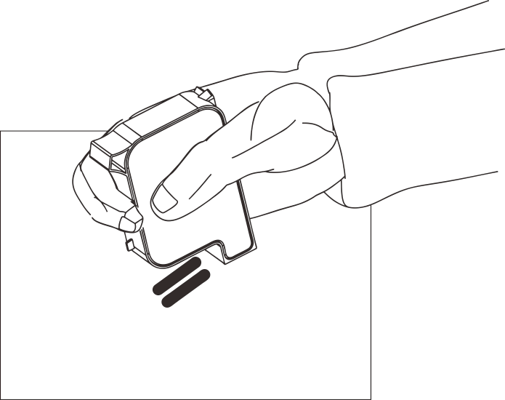

Figure 6-1

6. Do not shake the ink cartridge vigorously, because the ink pressure may damage the print head, and at the same time, it will cause bubbles inside the ink cartridge to affect the printing quality.

**In order to make you get the best printing quality, according to different types and specifications of ink, detailed precautions, maintenance, please contact our after-sales service staff for more instructions on ink usage.**

# Chapter 7 Common Problems and Solutions

## 7.1 Warning bar information status and solution

There are three background colors for the warning display bar:

Green: The machine status is completely normal

Yellow: The machine has an alarm, but it does not affect printing

Red: The machine has a fault alarm and cannot print normally

### 7.1.1 Display green

When the background color of the warning display bar is green, it means the machine is in a normal state

### 7.1.2 Display yellow

When the background color of the warning display bar is yellow, it indicates that the machine has an alarm, but it does not affect printing. It is used to remind the operator that the printer needs maintenance or information processing errors.

The following is a list of common alarms when the background color of the warning display bar is yellow:

Low ink cartridge level: The ink ink level in the ink cartridge is too low.

Solution: A new ink tank should be installed.

Encoder speed is too fast: The encoder speed exceeds the maximum sequence speed.（Note: This only occurs when using a rotary rotary encoder. )

Solution: reduce the speed of the encoder.

The service time of the machine is coming soon: The maintenance service hour of the machine is almost up.

Note: This warning is a setting that can be turned off, so it may not be displayed (the second time will be given when the machine maintenance service has arrived warning shutdown).

Solution: It can be closed in the service menu. If the fault cannot be eliminated, the maintenance personnel should be repaired.

Low battery power: The battery power of the machine is too low.

Note: This warning is only displayed on the handheld printer.

Solution: Reinstall the new battery or charge.

### 7.1.3 Display red

When the Background color of the warning display bar is red, it indicates that the machine has malfunctioned, and at the same time, printing has been stopped or unsafe conditions have been prevented. At this time, the operator makes corresponding treatment after confirmation. If the printer successfully returns to normal working status, the warning bar message will disappear accordingly.

**The following lists several common alarms when the background color of the warning display bar is red:**

Ink cartridge information cannot be recognized: the machine cannot read the information corresponding to the ink cartridge

Solution: Check whether the position of the ink cartridge is installed in place, reinstall or replace the ink cartridge

The ink cartridge is empty: the ink in the ink cartridge has run out.

Solution: A new ink cartridge should be installed.

No ink cartridge installed: no ink cartridge was detected before starting printing.

Solution: Install the ink cartridge, and install and check the ink cartridge before starting printing.

The ink cartridge is not locked: the clamping block of the ink cartridge is not locked.

Solution: After inserting the ink cartridge into the pinhole card slot, gently press the hand to fix the position of the ink cartridge buckle up.

Machine service time is up: The machine maintenance service hour has arrived, and the machine stops printing.

Note: This warning is a setting that can be turned off, so it may not be displayed.

Solution: It can be closed in the service menu. If the fault cannot be eliminated, the maintenance personnel should be repaired.

Ink cartridge has expired: cartridge life has expired

Solution: Install a new ink cartridge before starting printing again

## 7.2 Common problems and solutions of ink cartridges

|  |  |  |  |  |
| --- | --- | --- | --- | --- |
| **SN** | **Problem** | **Analysis** | **Solution** | **Remarks** |
| 1 | The printing effect is broken or white | Nozzle hole clogged or damaged | A. Refer to chapter 6.2 Ink cartridge maintenance instructions, wipe the nozzle clean with a non-woven cloth;  B. Press the one-button cleaning function of the operation steps in 5.4.5 to solve the problem. | If not resolved:  1.Please check whether the contacts of the nozzle drive board are recessed and cannot bounce;  2.Whether the ink cartridge contacts are dirty. |
| Ink cartridge and printer poor contact | Reinstall the ink cartridge or disassemble the ink cartridge, and check if there is any foreign object on the ink cartridge contact plate. |
| 2 | The printing effect appears to be complete in the front and only part of the content is printed in the **Cancel**. | Insufficient ink supply,  Air in the cartridge. | A.Please confirm whether the cartridge information indicates that it is almost used up;  B, use the suction clip to draw out the gas in the cartridge  C. Please send **Cancel** to our company for testing |  |
| 3 | Ink in ink cartridge  Fully printed  Not coming out。 | The ink cartridge has run out;the nozzle is severely blocked;  Cartridge voltage and pulse width  The parameter is wrong | A. Return to the "Information Editing" interface to check the remaining amount of ink to confirm whether the ink has run out  B.Enter the cartridge parameter interface to see if the parameters match  C. Replace with new ink cartridge |  |
| 4 | Cartridge not installed alarm | Inkjet printer contact bad touch or damaged | Reinstall the ink cartridge or replace with a new ink cartridge | If it is not resolved, please check:  1. Whether there is a depression in the contact of the drive board, which can not be bounced or damaged;  2. Whether the ink cartridge contacts are dirty |
| Ink cartridge information failed  Identify | Non-company RFID core;  The RFID chip is damaged;  RFID paste location offset:  other errors | Replace with a new ink cartridge:  Replace the RFID chip;  Reconfirm the RFID chip sticking position | If not resolved:  Please return to our company for testing |

## 7.3 Common problems and solutions of inkjet printers

|  |  |  |  |  |  |  |  |
| --- | --- | --- | --- | --- | --- | --- | --- |
| **SN** | **Problem** |  | **Analysis** | **Solution** |  | **Remarks** |  |
|  |  | 1.The printer has no electricity  Source input | | A. Make sure that the power adapter AC power input is correct, and the DC plug of the adapter is inserted into place with the printer;  B. Confirm whether the power indicator of the adapter is always on. If it is not bright, slightly bright or flashing, please replace the adapter. |  |  |  |
|  |  |  |  |  |
|  |  |  |  |  |
|  |  |  |  |  |
|  |  |  |  |  |
|  |  |  |  |  |
| 1 | Can not boot |  |  |  |
|  |  |  |
|  |  |  |  |  |
|  |  |  |  |  |
|  |  | 2The printer switch is not turned on | | Confirm that the printer switch is in the "ON" state. |  |  |  |
|  |  |  |  |  |  |
|  |  |  |  |  |  |
|  |  | 3. Equipment damage | | Please contact our after-sales service department. |  |  |  |
|  |  |  |  |  |  |
|  |  |  |  |  |  |  |
|  |  |  |  |  |  |  |  |
|  | Unable to print | 1.The"StartPrinting" button is not pressed | | Please confirm whether the printing status is in the printing status; press the "Start Printing" button next to the status bar |  |  |  |
|  |  |  |  |
|  |  |  |  |
|  |  |  |  |
|  | 2.No print data | | Select or edit the information and click the "Send Print" button |  |  |  |
|  |  |  |  |  |
|  |  |  |  |  |  |
|  |  | |  |  |  |  |
|  | 3.The printing delay is too large;  Resulting in no printing on the product | | Check if the printing delay is normal |  |  |  |
|  |  |  |  |
|  |  |  |  |  |
|  |  |  |  |
|  |  |  |  |  |
|  |  |  |  |  |
| 2 | 4.No cartridge | | Install ink cartridges |  |  |  |
|  |  |  |  |
|  | 5.There are ink cartridges, but ink cartridges  Used up or damaged; cartridge information is not identified; cartridge parameters do not match | | Follow step 7.2 to check the ink cartridge information to confirm whether the ink cartridge is used up or RFID chip problem; modify the system ink cartridge parameters according to the surface parameters of the ink cartridge to make it match | If the ink cartridge has run out, or the RFID problem, replace a new ink cartridge or RFID chip to solve. | | |
|  |
|  |
|  |
|  |
|  |
|  |
|  |
|  |
|  | 6.No optical signal | | Sensing the electrical eye signal by hand and checking whether the photoelectric eye is properly connected | If an external electric eye is connected, click "Main Menu"-"Printing Parameters"-"Printing Word Width" to check the effective level of the optical eye, and sense the electric eye by hand to test whether the electric eye is damaged | | |
|  |
|  |
|  |
|  |
|  |
|  |
|  |
|  | 7.There is an encoder, but the encoder is damaged;or the internal swipe rate generation source is selected | | Check the encoder connection line and confirm whether the encoder is damaged or the production line is running; change the stroke rate generation source to an external encoder | Click "Main Menu"-"Printing Parameters"-"Printing Word Width" to view the production line speed value, and continuously click the "Refresh" button to observe whether the production line speed display has changed to determine whether the test encoder is damaged | | |
|  |
|  |
|  |
|  |
|  |

**Note:**

**1. The above are only common faults and solutions, if there are other faults, please contact our after-sales service department;**

**2. According to the customer's on-site installation environment and operation requirements, the cause of the failure and the solution will be different. This method only provides a reference solution.**